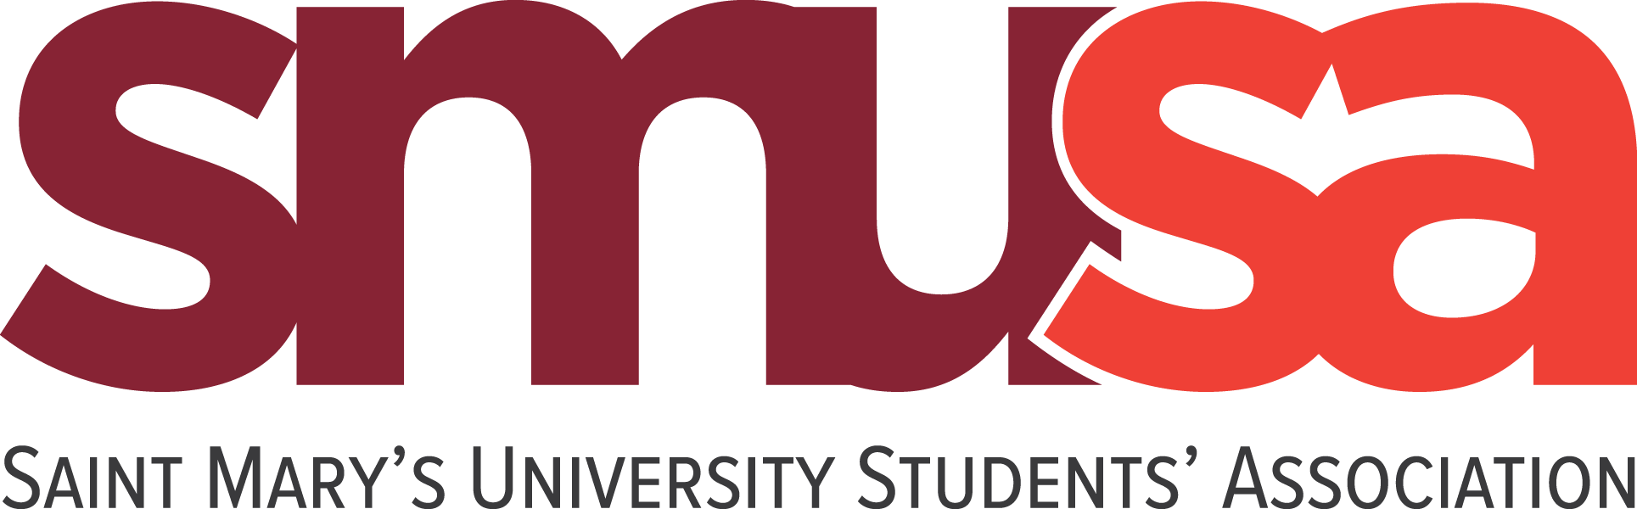

SMU Poster Policy
Amended March 2022

- Internal Posters: 35 Posters for a Period of up to 3 weeks
- External Posters: 20 Posters for a Period of up to 2 weeks
- All posters must be stamped and approved by the SMUSA information desk – this is a free service
- All posters should be no larger than 11 x 17
- Please do not cover other posters
- Please only use thumb tacks
- Posters are only allowed to be placed on cork boards on campus
- No stickers allowed
- SMUSA has the right to remove any posters that are not in compliance with the policy
- SMUSA, as well as yourself or your organization cannot advertise any external Restaurants, Bars, Pubs or Food Services and Gyms
- SMUSA, as well as yourself or your organization, cannot advertise anything that competes with Services offered on Campus in any capacity
- SMUSA, as well as yourself or your organization, cannot advertise anything that could be perceived as offensive
- SMUSA, as well as yourself or your organization, cannot advertise anything regarding pub crawls, Fraternities/Sororities, or alcohol externally

